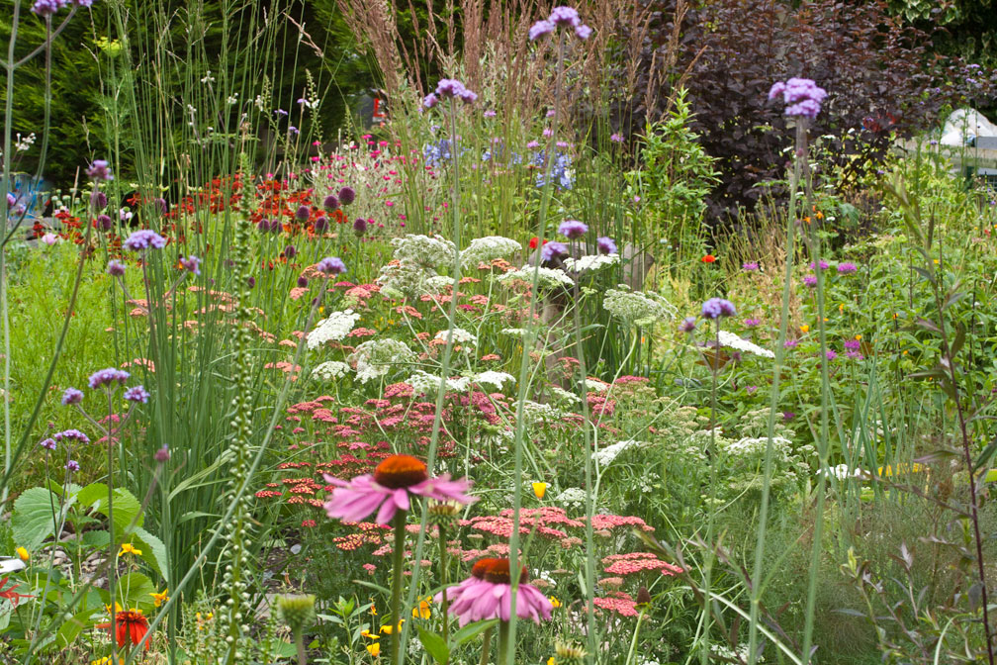
Cromarty Open Gardens
Saturday 9th July
11am. to 4pm
20 + gardens to view around our picturesque town!
and
Art & Flower Show in The East Church.

Tickets/garden guide (£3) from 'the hub' at
the old Fish Store.
(Children free. Guide dogs only please)

Further information available at the community market in
Victoria Hall between 11am and 2pm.
Refreshments are available at the community market or various tea-shops, cafes or hotels around town.
There will be a plant stall at the hub.

All funds raised will be donated to local charities: Cromarty Care Project, Fourways.

